**Purdue English Writing 2577  
ISTM Spring Semester 2023 Class date: May 24/ Week 15**

**Model answer**

The bar chart shows the actual and projected share of the economy of Brazil held by the five key business sectors for the years 2009, 2019 and 2029. Overall, for the period covered, the Finance sector stands out in terms of having the largest share of Brazil’s economy and its share shows continued growth. The big loser is manufacturing, which starts as the joint smallest sector and sees both real and projected falls.

Beginning with the real figures, the sectors that saw growth between 2009 and 2019 are Finance, Fossil Fuels and Food Processing with rises of around 5 percent for the two former and around 10% for the latter. However, both Tourism and Manufacturing saw falls of around 5% for that period.

Turning next to the projected figures for 2029, only the Finance sector is predicted to see a continued growth in 2029, again by 5%. Of the remaining sectors, tourism stays at 2019 levels with around 21% and both Food Processing and Oil, Coal and Gas return to 2009 levels (11 and 26% respectively). Meanwhile, Manufacturing sees a further drop in its share, falling by a further 10 percent to around 5 percent.

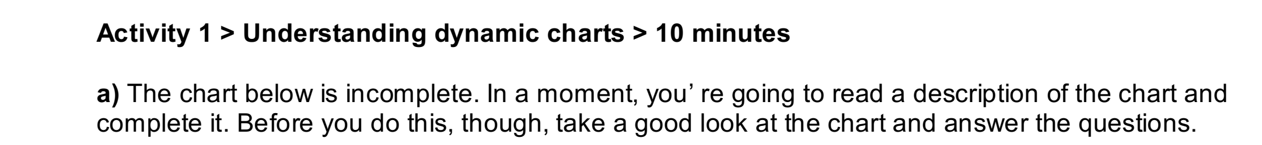

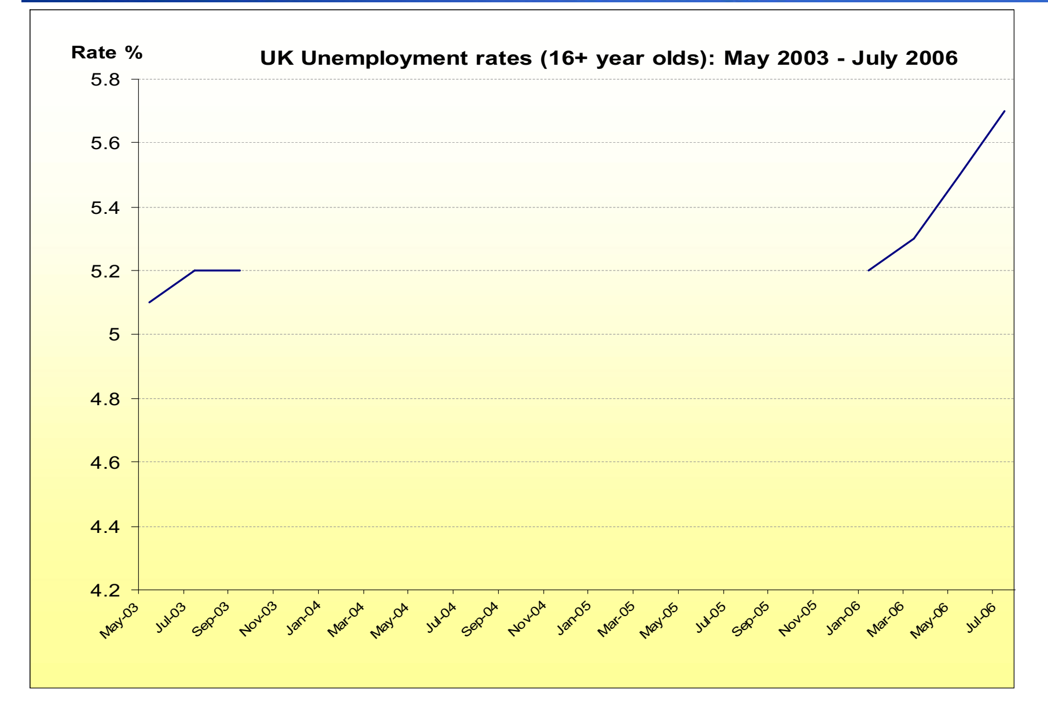

1 What kind of chart is this?  
a) A pie chart  
b) A line graph  
c) A proportional bar chart

2 What does the chart show?  
a) The percentage of the workforce over 16 who were unemployed  
b) The percentage of the workforce over 16 who are unemployed  
c) The number of people over 16 who were unemployed

3 What are the units shown in the vertical axis (going up)?  
a) hundreds  
b) thousands  
c) percentages

4 What period does the chart cover?  
a) Just over 3 years  
b) Almost 3 years  
c) Just over 2 years

5 What was the unemployment rate at the beginning of the period?  
a) 5 per cent  
b) 5.1 per cent  
c) 5.2 per cent

**b)** Now read the description of the chart and draw the missing section of the line graph.

The line graph shows figures for unemployment in the UK workforce between May 2003 and July  
2006. It is clear from the chart that the rate of unemployment **fluctuated a great deal** during this  
time. At the beginning of the period, unemployment stood at 5.1 per cent. A few months later the  
figure **had risen slightly** to 5.2 per cent. Unemployment then **remained stable** until September  
2003. From this point on **there was a steady downward trend** and by January 2004 the rate **had  
fallen to** 4.9 per cent. It **stayed at this level** until May the same year, but from May to July **there  
was another small drop** of 1 per cent. There were no further changes in the level of unemployment  
until March the following year. From March to May 2005, **there was a small increase** of 1 per cent,  
but this did not last long and the figure had fallen back to 4.8 per cent by July. From September 2005  
onwards, however, **there was a marked upward trend** in the rate of unemployment in the UK. From  
September 2005 to November the same year, **the figure shot up** from 4.8 to 5.2 per cent. The rate  
remained stable for a few months, but then **rose sharply** again, and had **reached a peak** of 5.7 per  
cent by July 2006.

**c)** The highlighted words in the description of the chart that you’ve just read are useful phrases for  
**describing increases and decreases**. Read the report again and find phrases from the text which  
mean… **Answers  
went up and down frequently  
did not change (2 phrases)  
went up a little  
went up very quickly (2 phrases)  
arrived at its highest point  
went up noticeably over a period  
went down (2 phrases)  
went down gradually over a period**

**Activity 2 >** Describing increase and decrease (1) > **10 minutes**

a) In the last task you learned some useful phrases for describing increases and decreases. There are also two useful sentence structures for doing this:

**1 [noun phrase] + [verb] + [adverb]**

For example: The unemployment rate rose rapidly

The cost of living fell dramatically

**2 [There is/are] + [noun phrase]**

For example: There was a rise in unemployment

There has been an increase in the cost of living

**Finish each sentence below so that it means the same as the one given.**

1 The price of oil rose sharply.

**There…**

2 There is a noticeable increase in temperature from May onwards.

**Temperature**…

3 The number of people attending the theatre has fallen dramatically.

**There**….

4 There had been a steady rise in DVD sales for the first six months of the year.

**DVD sales…**

5 There has been a rapid growth in the use of alternative energy sources.

**The use of alternative energy sources…**

6 The popularity of self-catering holidays decreased significantly during the 1990s

**There…**

**Activity 3 > Describing increase and decrease (2) > 10 minutes: on the exercise paper**You can also describe increases and decreases by using fractions to show the size of the change  
over a certain period. For example:  
The cost of rents **doubled** in less than a year.  
Birth rates **have halved** since the turn of the century.  
By July, the price of petrol had fallen **by a third.**The number of school leavers going on to university has risen **by a quarter** since 1980.

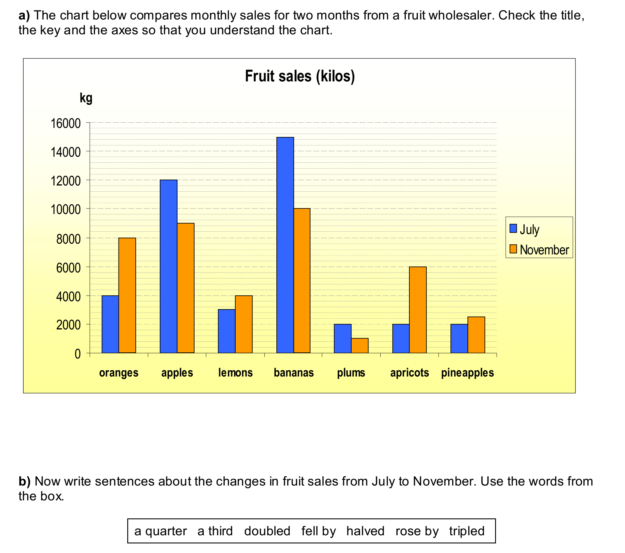

**Orange sales doubled. (example) Apple sales fell by a quarter.**

Lemon sales… Bananas sales… Plums sales… Apricot sales…

Pineapple sales…

**b)**Now write sentences about the chart below, which shows changes in the quantities of imports of  
certain electronic goods. Again, use the words in the boxes. **Write on the class exercise paper.**

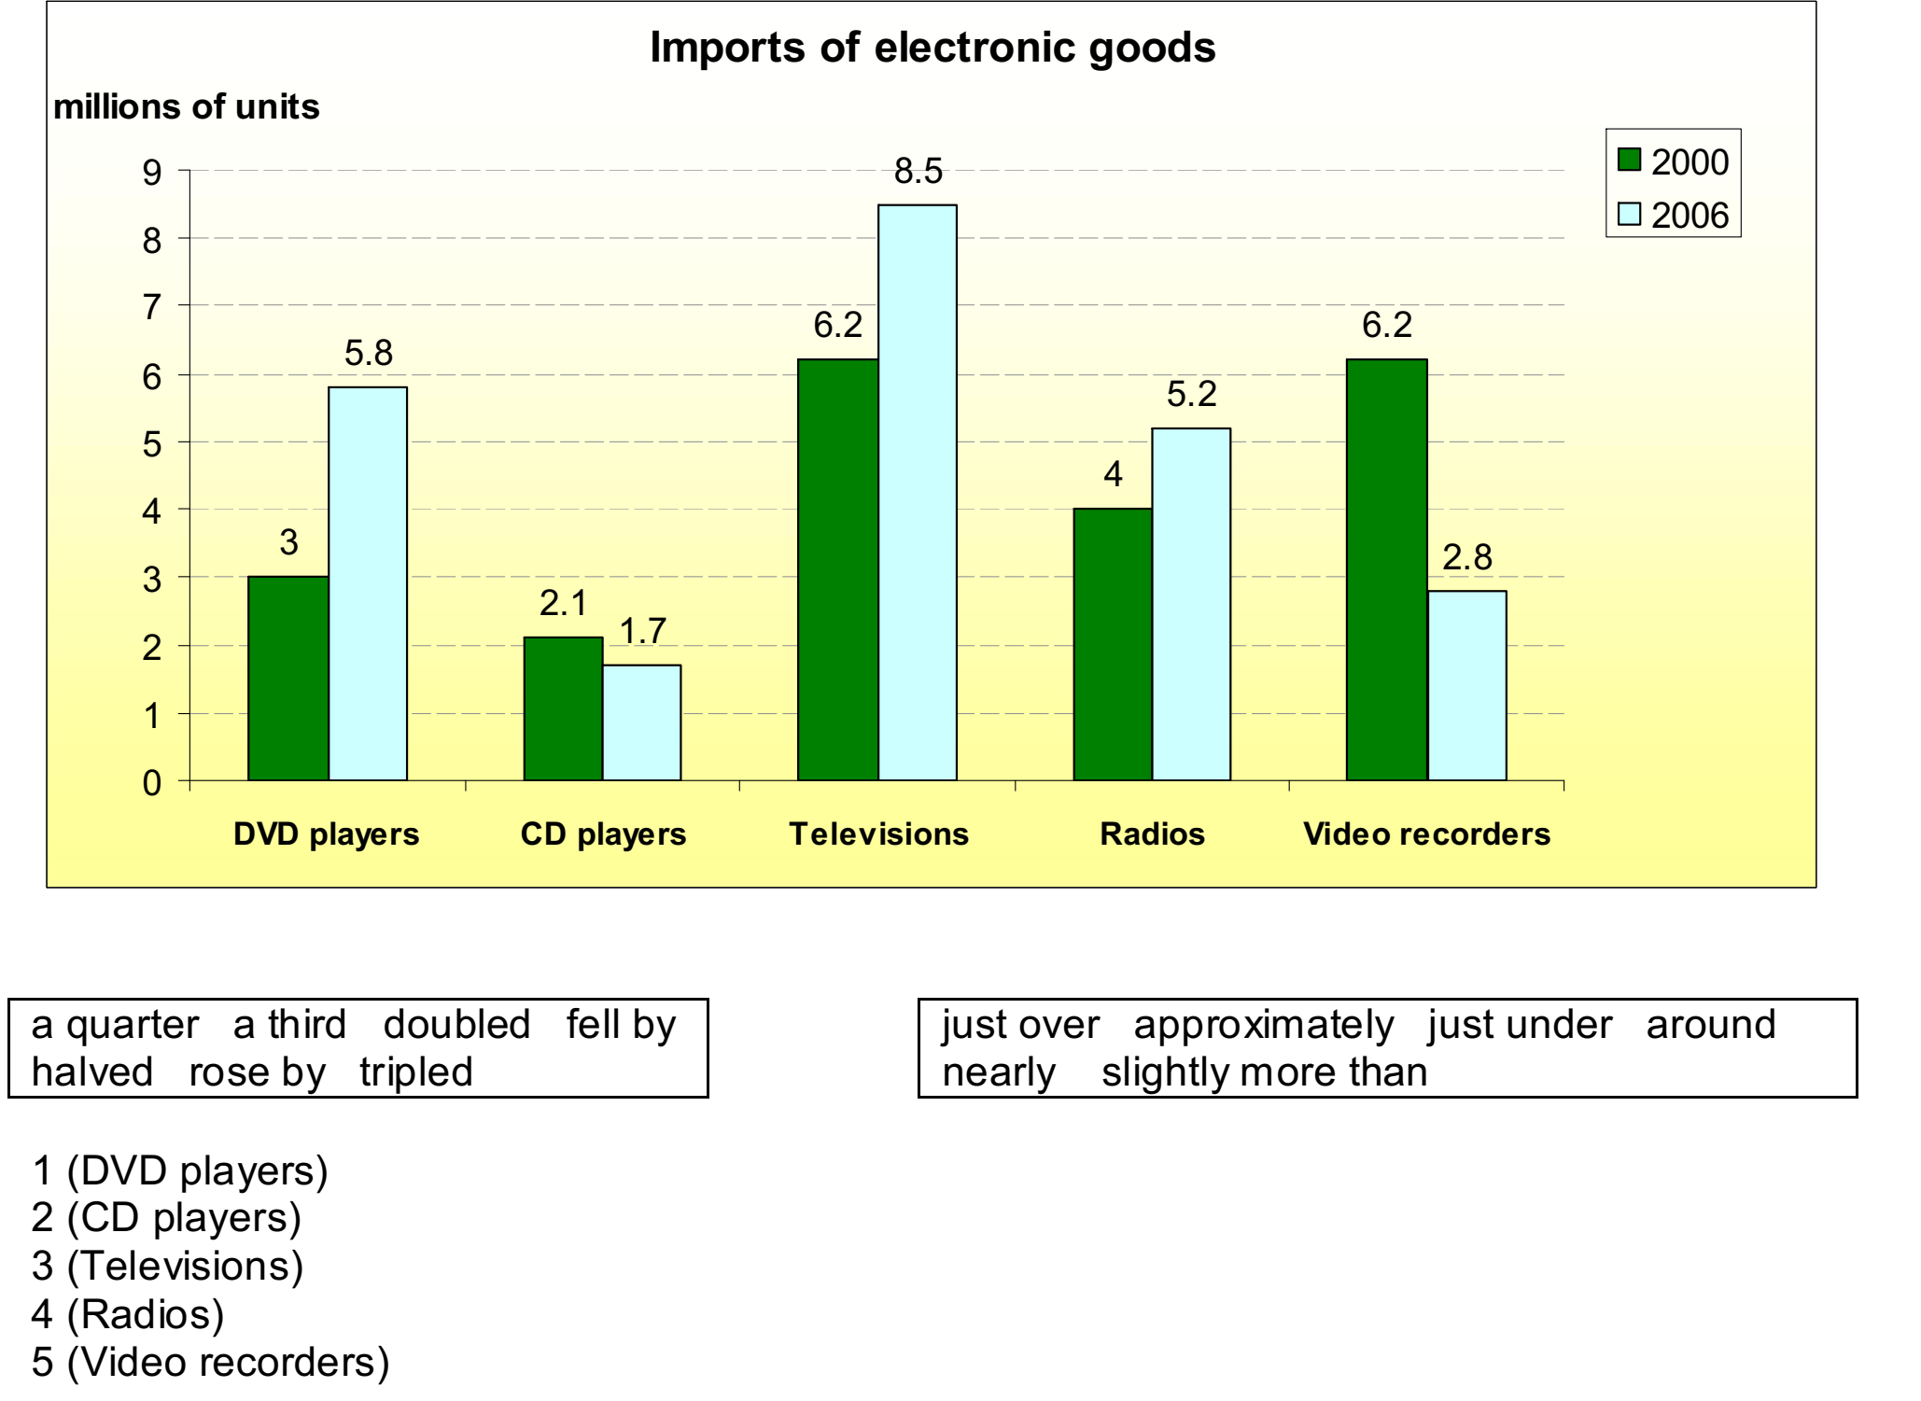

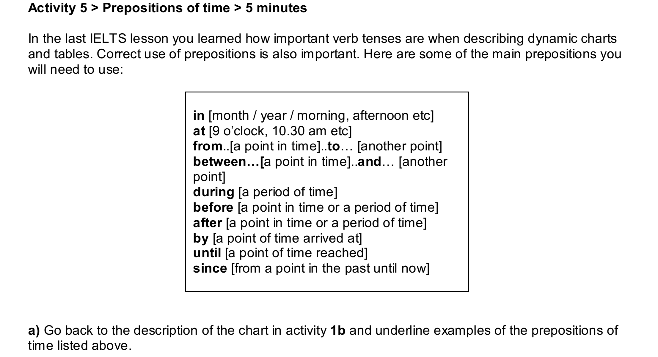

**b)** Now complete each of these sentences with the correct preposition.  
1 **………** January there was a noticeable rise in the number of people taking sick leave from work.

2 Temperatures usually reach a peak **………** about 1 o’clock in the afternoon.  
3 From 1997 **………** 2006 there was a steady increase in sales of organic produce.  
4 **………** the recession, unemployment grew steadily.  
5 Televisions audience viewing figures rise dramatically **………** 6 o’clock in the evening.  
6 **………** June sales figures were low, but later they began to increase rapidly.  
7 The price of oil had shot up to $70 per barrel **………** August.  
8 From November **………** the end of the year energy consumption continued to rise.  
9 There has been a marked decrease in road accidents **………** the new laws were introduced in  
2005.

**Basic IELTS Task 2 Writing Template Structure**

**I would recommend that your essay uses the following structure:**

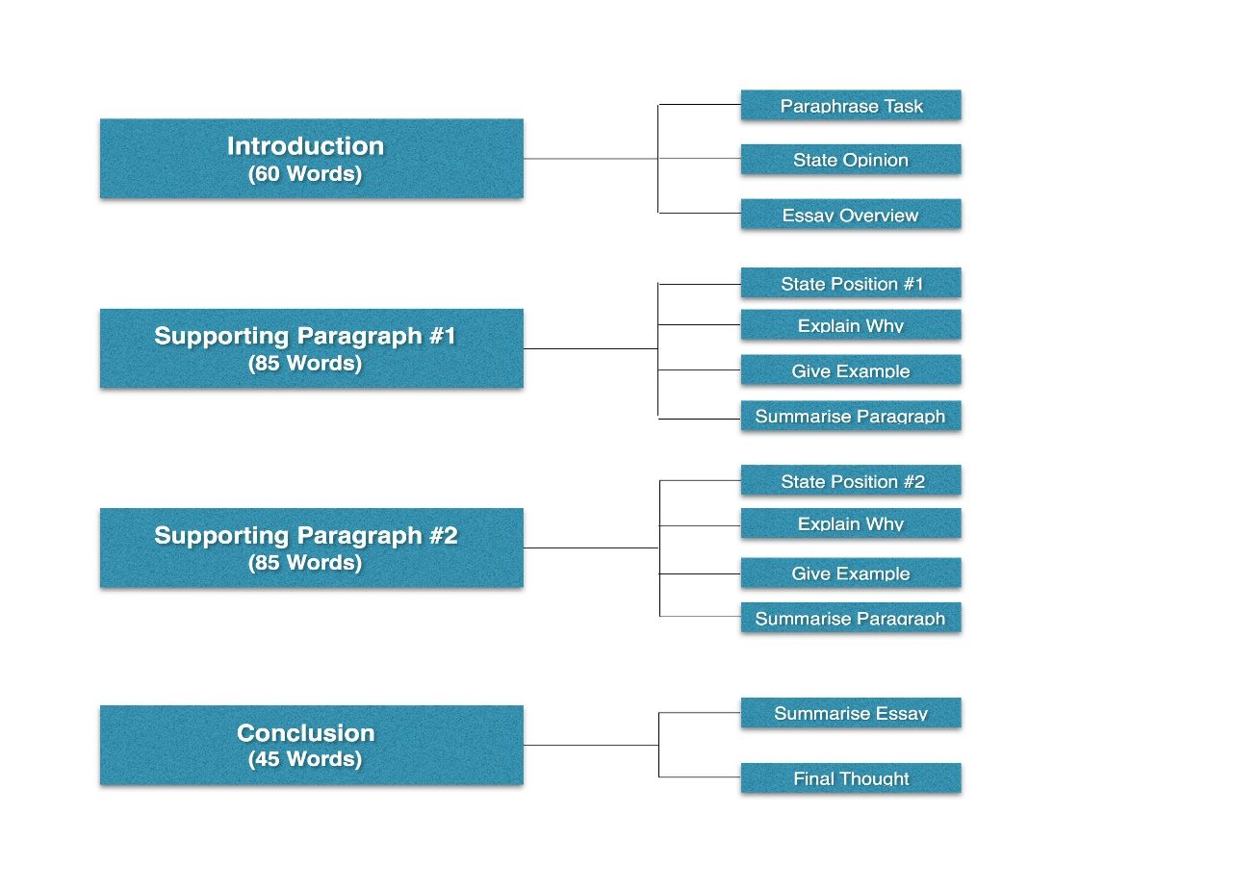

Below is more detail on the sentences that should be contained within each of these paragraphs along with examples based around this sample Task 2 Question:

***Government investment in the visual arts, the kind you commonly see in art galleries, is a waste of money. Governments must invest this money in public services instead. To what extent do you agree with this statement?***

**Introduction**

Aim to write three sentences around 60 words in total.

* **Sentence 1 – Paraphrase the task question** or write a general statement relating to the topic using synonyms of the key words used in the question. *E.g. These days, many local governments spend large portions of their budget not only on public services, but also on the visual arts.*
* **Sentence 2 – State your opinion** or point of view on the question being asked. *E.g – Although I agree that it is important to invest in local amenities, I do not think spending on the visual arts is a waste of money.*
* **Sentence 3 –  Give an essay overview** including a summarizing phrase like: *E.g. This essay will discuss this issue using examples to support arguments and demonstrate points.*

**Supporting Paragraphs**

The two supporting paragraphs should include your ideas and supporting examples to answer the task question. Aim to write only two supporting paragraphs with roughly 85 words in each. Each paragraph should contain the following four sentences and stick to one idea per paragraph:

**Paragraph 1:**

* Sentence 1 – **State your 1st position.** *Eg. On the one hand, spending a significant amount of the government budget on public services is beneficial for society.*
* Sentence 2 – **Explain why** you hold that position. *Eg. Providing for basic amenities, such as hospitals, roads, and schools, helps to determine the quality of life that most citizens will have.*
* Sentence 3 – **Give an academic example** that backs up your idea. *Eg. For example, a recent survey by Education Today shows that countries that spend more on schools have a population that is higher in literacy, by 65%, compared to those that dedicate no money to education.*
* Sentence 4 – **Summarise the paragraph** showing how your example links your idea/argument back to the main idea.*Eg. Therefore it is apparent that spending on public services is a worthwhile investment for a government.*

**Paragraph 2:**

* Sentence 1 – **State your 2nd position.**
* Sentence 2 – **Explain why you hold that position**
* Sentence 3 – **Give an academic example**that backs up your idea.
* Sentence 4 – **Summarise the paragraph** showing how your example links your idea/argument back to the main idea.

**Conclusion**

For the conclusion, aim to write just one or two sentences that paraphrase what you’ve discussed in the essay. Try to keep to under 45 words.

* Sentence 1 – **Summarise the essay.** Be sure to start this sentence with an appropriate linking phrase (i.e. In conclusion, To sum up, Consequently) followed by an overall summary of what you’ve just written. *E.g. To sum up, although there are clear benefits of ensuring a large amount of investment goes into public services, I do not believe spending money on the arts is a waste of money as this too provides important benefits.*
* Sentence 2 – **Give a Final Thought.** *Eg. In the future, governments should consider budgeting for both.*

**Now follow this structure** for this question: **Write on the class exercise paper.**

**Now write this essay, including the introduction, 2 body paragraphs and the conclusion.**

**Give reasons for your answer and include any relevant examples from your own knowledge or experience.**

***Some people think that art is an essential subject for children at school while others think it is a waste of time.***

***Discuss both views and give your opinion.***

**Write at least 250 words.**